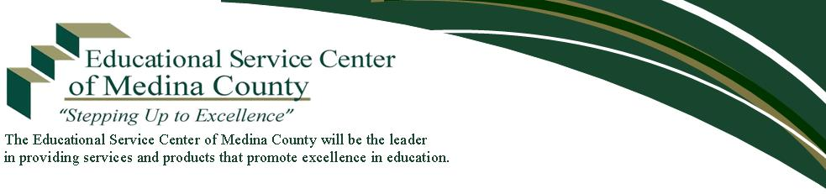
PRESS RELEASE

2020 Medina County

Solo and Ensemble Festival

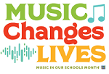
Over 150 students participated in the 2020 Medina County Solo and Ensemble Festival, which was held on Saturday, February 8, at Buckeye High School.
Greg King (band director at Buckeye High School) and Pam Haberkorn (choir director at Buckeye High School) served as festival coordinators. Ohio Music Education Association (OMEA) qualified adjudicators gave performance ratings and verbal comments to students participating in the event. Superior and excellent ratings for this year’s events are included on the following pages.

The festival was held with the generous support of: Buckeye Local Education Association; Kerricook Construction, Inc.; Mack’s Inc.; Romeo’s Pizza; Royalton Music Center; Valley City VFW Post 5563; and individual community patrons. This event was coordinated by the Educational Service Center of Medina County and hosted by Buckeye Local School District.

For additional information, contact:
Greg King, Festival Co-Coordinator
(330) 722-8257, Ext. 3038
gking@buckeyeschools.org
or
Brenda Zacharias, Secretary
Educational Service Center of Medina County
(330) 723-6393, Ext. 101
bzacharias@medinaesc.org

Brunswick City Schools

Students of: Kimberly States (private), Jeannette Timko, and Debbie Woods (private)

Superior Ratings
Deza Frega | Flute Solo | High School
Cara Garrity | Flute Solo | Willetts Middle School
Josie Henson | Flute Solo | High School
Sharandeep Kaur | Flute Solo | High School
Ilsa Miller | Flute Solo | High School
Hailey Peterseim | Vocal Solo | High School
Avery Pyo | Vocal Solo | Towslee Elementary
Maggie Romano | Vocal Solo | Willetts Middle School
Brady Roth | Piano Solo | Edwards Middle School
Sarah Tyler | Flute Solo | High School
Skye Zielaskiewicz | Flute Solo | Visintainer Middle School

Sweet Melody Flute Ensemble | Flute Ensemble | High School

Excellent Rating
Kyra Whelan | Flute Solo | High School

Buckeye Local Schools

Students of: Pam Haberkorn, Chien Hui Haynes (private), Greg King,
Adrienne Leska, Kimberly States (private), and Debbie Woods (private)

Superior Ratings
Lizzie Berkheimer | Vocal Solo | Jr. High School
Clare Bohan | Vocal Solo | Jr. High School
Grace Bohan | Vocal Solo | Jr. High School
Kemrey Cerny | Snare Drum Solo | Jr. High School
Alex Crooks | Snare Drum Solo | High School
Lexi Dacek | Vocal Solo | Jr. High School
Aimee Duchanse | Vocal Solo | High School
Madison Dudas | Vocal Solo | Jr. High School
Samantha Gauthier | Vocal Solo | Jr. High School
Justin Hoschouer | Trumpet Solo | High School
Savannah Kemp | Vocal Solo | High School
Nicole Laurence | Clarinet Solo | High School
Haley Madak | Flute Solo | Jr. High School
Josette Moran | Vocal Solo | High School
Paige Nemeth | Vocal Solo | Jr. High School
Paige Pedmo | Vocal Solo | Intermediate School

Buckeye Local Schools (cont.)

Superior Ratings (cont.)
Mya Roberts | Vocal Solo | Jr. High School
Phil Serina | Piano Solo | High School
Jonathan Stahl | Trumpet Solo | High School
Nicholas Tenenika | Snare Drum Solo | Jr. High School
Emma Walters | Flute Solo | Jr. High School

7th Grade Ensemble | Vocal Ensemble | Jr. High School
8th Grade Ensemble | Vocal Ensemble | Jr. High School
Buckeye Trombone Duet | Trombone Duet | High School
Luke Mullins and Briana Madrigal | Baritone-Tuba Duet | High School
Olivia Eberts and Kali Walter | Flute-Marimba Duet | Jr. High School
Sweet Melody 7th Grade Ensemble | Flute Ensemble | Jr. High School

Excellent Ratings
Madison Krakowski | Vocal Solo | Jr. High School
Evelyn Page | Vocal Solo | Jr. High School
Mikayla Serrano | Vocal Solo | Jr. High School

Highland Local Schools

Students of: Rachel Gamin, Chris Ilg, Emily Miller, and Nate Rudolph

Superior Ratings
Ava Betlee | Vocal Solo | Middle School
Samantha Budd | Vocal Solo | Middle School
Alex Curtis | Tuba Solo | Middle School
Nicole Grimes | Piano Solo | Middle School
Noah Hayes | Vocal Solo | Middle School
Ellie Hollingsworth | Vocal Solo | Middle School
Jayna Jones | Vocal Solo | High School
Nastia Koval | Flute Solo | Middle School
Carter Mull | Tuba Solo | Middle School
Kayla Seiler | Vocal Solo | Middle School
Tyler Shepard | Vocal Solo | Middle School
Kylee Studd | Flute Solo | Middle School
Kylee Studd | Vocal Solo | Middle School
Hailey Tramonte | Vocal Solo | Middle School

Highland Local Schools (cont.)

Superior Ratings (cont.)
7th Grade Duet–Butcher and Natarajan | Alto Sax-Trumpet Duet | Middle School
7th Grade Trio–Farr, Hummel, Bryan | Instrumental Ensemble | Middle School
7th Grade Trio–May, Brainard, Konyate | Clarinet-Trumpet Trio | Middle School
8th Grade Duet–Csizmadia and Weber | Tuba-Saxophone Duet | Middle School
Lucy Freund and Olivia Swiatkowski | Vocal Duet | Middle School
Marinelli and Simon Duet | Woodwind Duet | Middle School

Excellent Ratings
Lilly Barney | Vocal Solo | Middle School
Sydney Campbell | Alto Saxophone Solo | Middle School
Marley Carter | Percussion Solo | Middle School
Cadence Heaton | Vocal Solo | Middle School

7th Grade Duet–Cole and Gray | Flute-Trumpet Duet | Middle School
Andrews and Potak Duet | Brass Duet | Middle School
Boggs, Basemore, and Gray Trio | Woodwind Trio | Middle School
Silver, Clark, and Marinelli Trio | Alto Saxophone Trio | Middle School

Medina City Schools

Students of: Melinda Kline (private), Kimberly States (private),
and Debbie Woods (private)

Superior Ratings
Portia Becks | Vocal Solo | High School
Gabby Cook | Vocal Solo | Root Middle School
Lillian Ivey | Flute Solo | High School
Mia Marsala | Vocal Solo | High School
Leah Medley | Piano Solo | Garfield Elementary
Brooke Milewski | Vocal Solo | Claggett Middle School
Grace Sundaram | Piano Solo

Excellent Ratings
Carleigh Johns | Vocal Solo | Claggett Middle School
Katherine Johns | Vocal Solo | Northrop Elementary

Nonpublic Schools

Students of: Kimberly States (private), Jeannette Timko (private),
and Joshua Wortman (St. Ambrose)

Superior Ratings
McKayla Bergman | Vocal Solo | St. Francis School
McKenna Buie | Piano Solo | St. Ambrose School
McKenna Buie | Vocal Solo | St. Ambrose School
Sarah Cigany | Piano Solo | St. Ambrose School
Sarah Cigany | Vocal Solo | St. Ambrose School
Benjamin Dietrich | Vocal Solo | St. Ambrose School
Piper Hadad | Vocal Solo | St. Francis School
Chelsea Kacinari | Vocal Solo | St. Ambrose School
Lainey Miller | Vocal Solo | St. Francis School
Olivia Morgan | Piano Solo | St. Ambrose School
Evan Stracensky | Vocal Solo | St. Ambrose School
Emma Takacs | Vocal Solo | St. Ambrose School

Superior Rating
Hayden Ansberry | Piano Solo | St. Ambrose School
- END -

