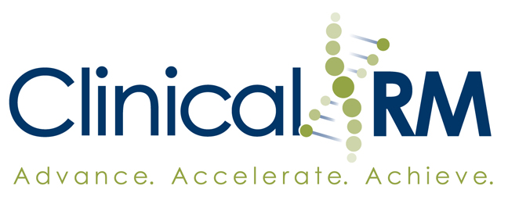

Clinical Research Management, Inc.
&
Medina County Public Schools

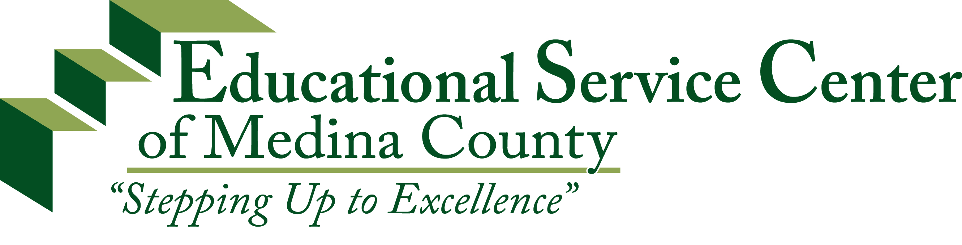
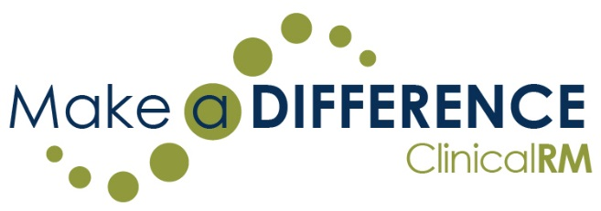

2017-2018

A Competitive Science, Technology, Engineering, & Mathematics
Education Grant for K-8 Science Teachers in Medina County

Please place this cover sheet on TOP of the entire grant application
ClinicalRM GRANT APPLICATION

Teacher / Applicant Name: Click here to enter text.

Medina County School Name: Click here to enter text.

Title of Proposal: Click here to enter text.
Clinical Research Management, Inc. (ClinicalRM) STEM Grant Offering
ClinicalRM has made a conscientious decision to grow its business in Medina County. As a token of our commitment to the area, we have decided to offer this grant to educators in recognition of the important service they provide. ClinicalRM believes that the future of our country and its citizens is directly tied to our ability to compete effectively in the global economy. We hope other companies and organizations, within the county, will join with ClinicalRM to provide our students with the necessary tools to secure our shared future.
ClinicalRM will award one $5,000 grant to a K-8 teacher or team of teachers in the Science, Technology, Engineering, and/or Mathematics (STEM) subject areas that addresses the purposes listed below.

Grant Purpose
- Create interest in careers within the STEM fields among K-8 school students.
- Increase awareness of careers in STEM fields in Medina County.
- Increase use of community resources in K-8 STEM school curriculum delivery.

Timeline
- December 2016 – May 2017 Grant Announcement communications from ESC of Medina
County
- August 4, 2017 Due Date – 4:00pm (Grant to ESC of Medina County)
- August 14, 2017 ESC of Medina County to turn in three finalists to ClinicalRM
- August 25, 2017 ClinicalRM to return final decision to ESC of Medina County
- August 28, 2017 Grant Award Announcement
- September 4 – September 8, 2017 Grant Award Presentation
- June 4, 2018 Grant Completion
*Dates subject to change based upon ESC of Medina County and individual winner availability

Application Process
- Grant application must be submitted to the ESC of Medina County, Janelle Sailer, by August 4, 2017 @ 4:00pm.
- The total amount of the grant request should not exceed $5,000. Local funds or other grant funds may be used to increase the scope of the grant.
- All sections of the grant must be completed.
- A grant review team composed of ESC of Medina County representatives, ClinicalRM representatives, and (optional) private sector representatives that work in a STEM field will select the winning grant.
- The grant award will be announced August 28, 2017.
- The fiscal agent for the grant will be the ESC of Medina County Office.

Project Ideas
One of last year’s winners from another school district proposed an after school club where students participated in an ‘Air Guitar Hero’ project where they worked with local engineers and a doctor in prosthetics to create a device that allowed them to play ‘Guitar Hero’ without using their hands or an instrument controller. The websites below can provide you with a number of science and technology based project ideas:
- http://blog.makezine.com/category/science/?post_type=projects
- http://www.instructables.com
- http://kids.nationalgeographic.com/kids/activities/funscience/
- http://explorable.com/kids-science-projects
- http://www.sciencekids.co.nz/experiments.html
- http://www.tryscience.org/home.html
- http://pbskids.org/zoom/activities/sci/
- http://www.funology.com/laboratory/
- http://www.newtonsapple.tv/TeacherGuides_alphabet.php
- http://galaxy.net/~k12/#subject
- http://www.reekoscience.com/Experiments/
- http://www.scienceoutreach.org/science_mania/activities.htm
- http://www.wackyuses.com/madscientist.html
- http://www.geocities.com/TelevisionCity/Set/4567/ex.html
- http://www.hunkinsexperiments.com/
- http://www.stevespanglerscience.com/experiments/
- http://www.thenakedscientists.com/HTML/content/kitchenscience/
- http://www.sciencebob.com/experiments/index.php
- http://membership.acs.org/C/Chicago/ChmShort/kidindex.html
- Questacon, a hands-on museum in Australia: http://www.questacon.edu.au/activities/
- Spark Lab is a project of the Smithsonian: http://sparklab.si.edu/spark-experiments.html
- http://www.lawrencehallofscience.org/kidsite/
- Chicago’s Museum of Science and Industry: http://www.msichicago.org/online-science/activities/
- http://kitchenpantryscientist.com/
Section A: Project Description

- Grade Level(s) to be Involved in Project
Click here to enter text.

- Goals & Objectives of Project
Click here to enter text.

- STEM Fields Included in Project
Click here to enter text.

Section B: Components

- Teacher Training (15 points)
(e.g. Workshops, seminars, university class, partnership meetings, teacher team meetings)
Click here to enter text.

- Community Partnerships (20 points)
(e.g. University, NASA, COSI, scientific company, high school science staff, high school students)
Click here to enter text.

Section B: Components (cont.)

- Implementation (10 points)
(e.g. Delivery strategies, time line)
Click here to enter text.

- Evaluation (15 points)
(e.g. Pre/post test, pre/post student survey, teacher survey, partnership evaluation)
Click here to enter text.

Section B: Components (cont.)

- Share the Success (20 points)
(e.g. Another classroom, another school in same district, another school in different district, board presentation)
Click here to enter text.

- Sustainability (20 points)
(e.g. How will the program be continued after the grant period?)
Click here to enter text.

Section C: Grant Budget (Not to Exceed $5,000)

Describe activities, materials, and/or equipment needed to implement the grant and estimate the cost in each category.

- Training Cost
Click here to enter text.

- Personnel Cost
(May include substitute teacher cost for training, planning, partner meetings and team meetings.)
Click here to enter text.

Section C: Grant Budget (cont.)

- Materials & Supplies
Click here to enter text.

- Equipment
Click here to enter text.

Signature Page

Please have relevant parties sign and date below.

Teacher Applicant Date

Teacher Applicant Date

Teacher Applicant Date

Teacher Applicant Date

Building Principal Date

ESC of Medina County Representative Date

Instructional Director for Secondary Date

District Superintendent Date

